AWS CHALLENGES

- Launch oneEC2 instance using Amazon Linux 2.
Sign in to console
Launch EC2 Instance
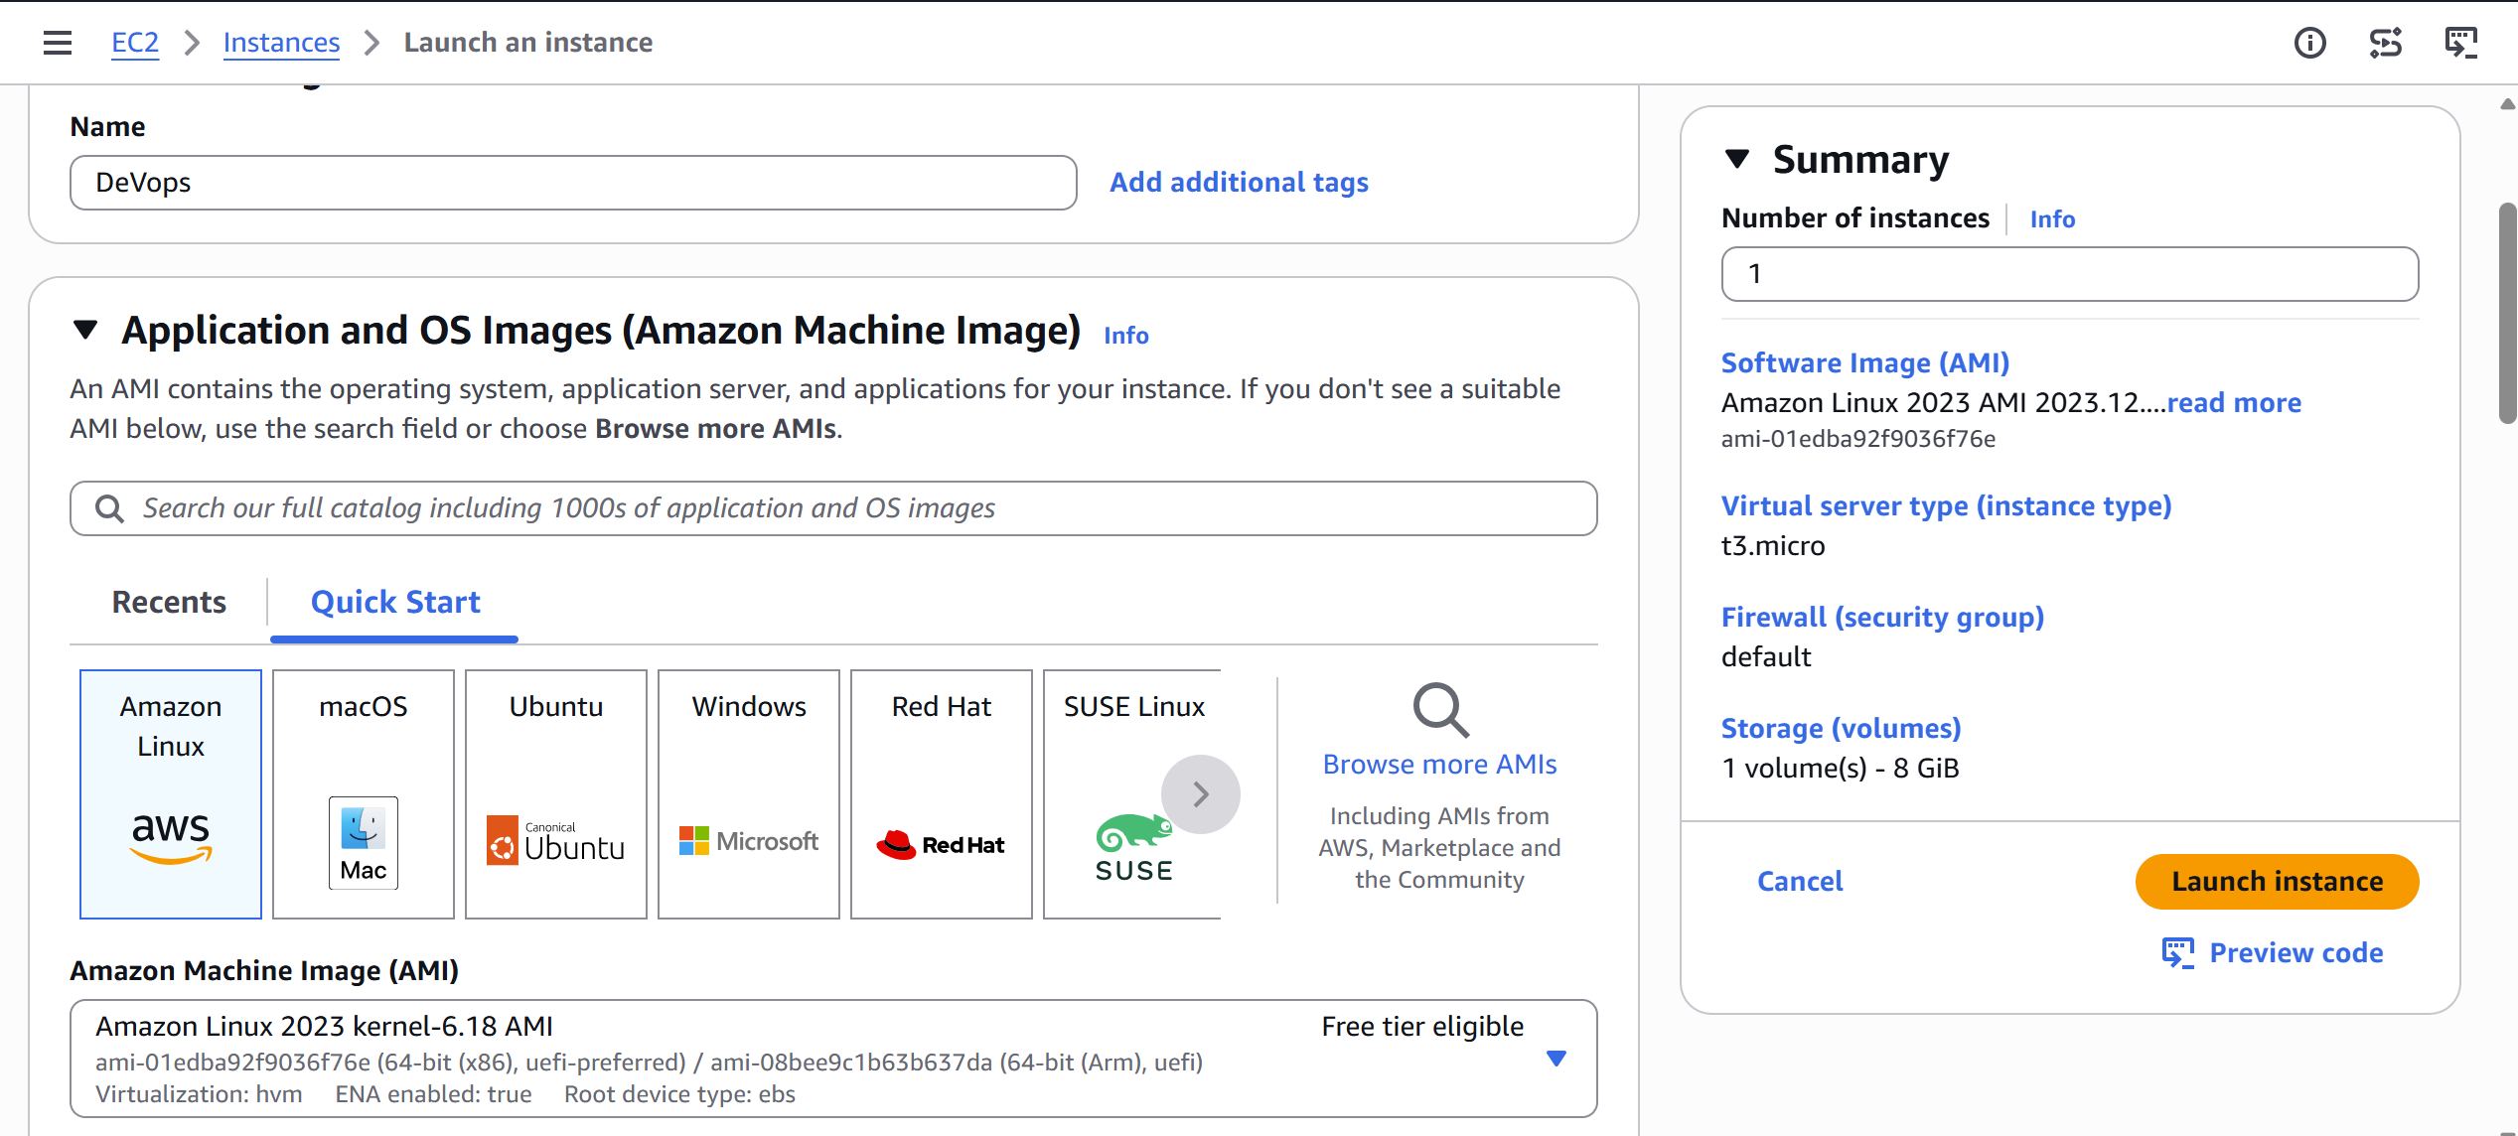
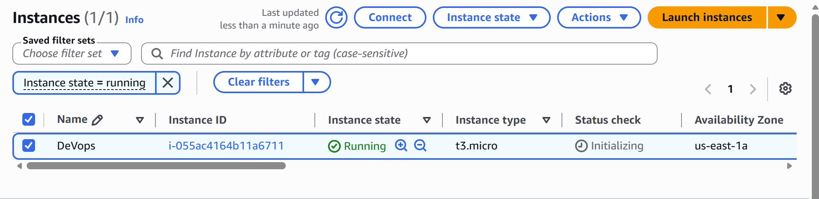
Ssh -I aws-.pem ec2-user@44.205.5.21
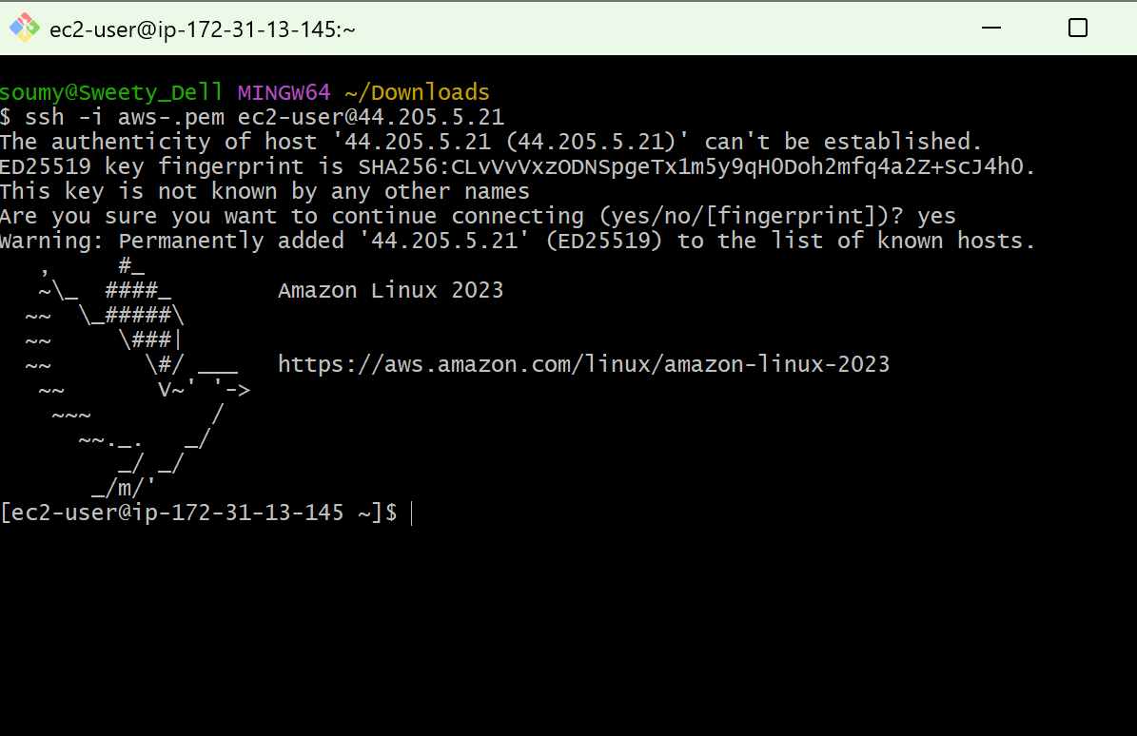
Check os
Cat /etc/os-release
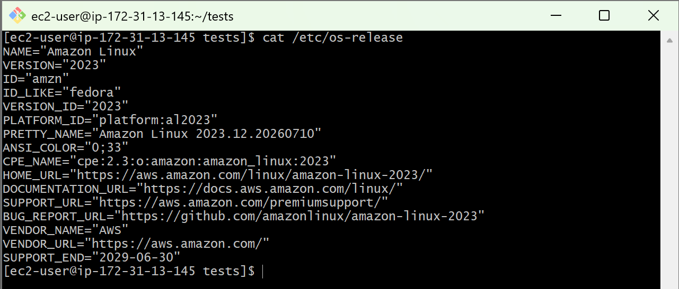

- Install Docker.
sudo dnf update -y
sudo dnf install docker -y

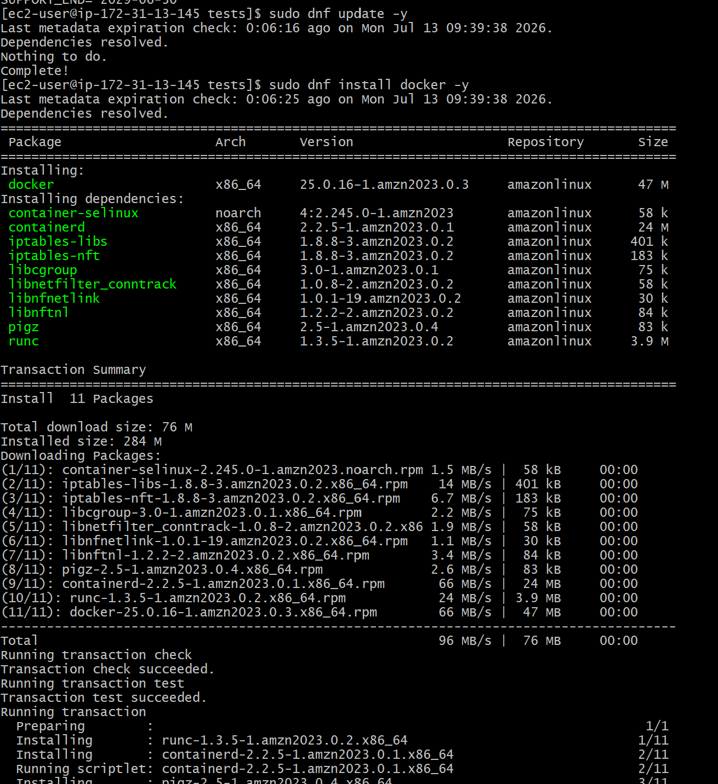
Start and enable Docker:
Sudo systemctl start docker
Sudo systemctl enable docker
Verify:
Docker --version
Check status
Sudo systemctl start docker

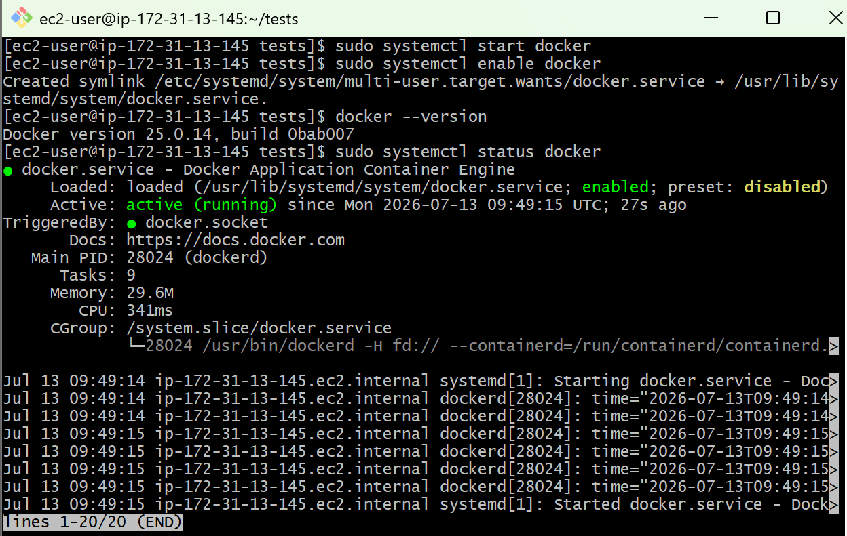

- Install java
- Check java version
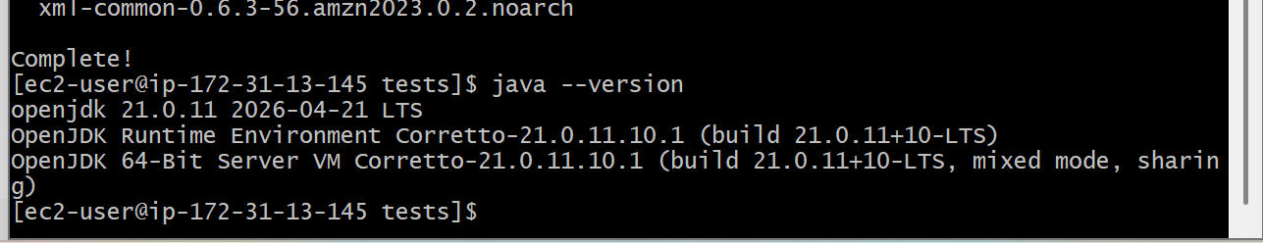
- Install Jenkins
Add the Jenkins repository
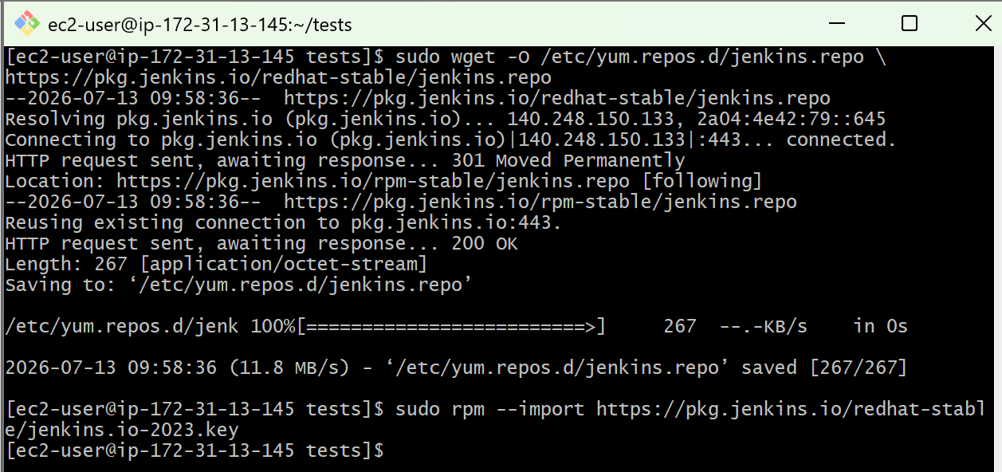
Sudo dnf install Jenkins -y
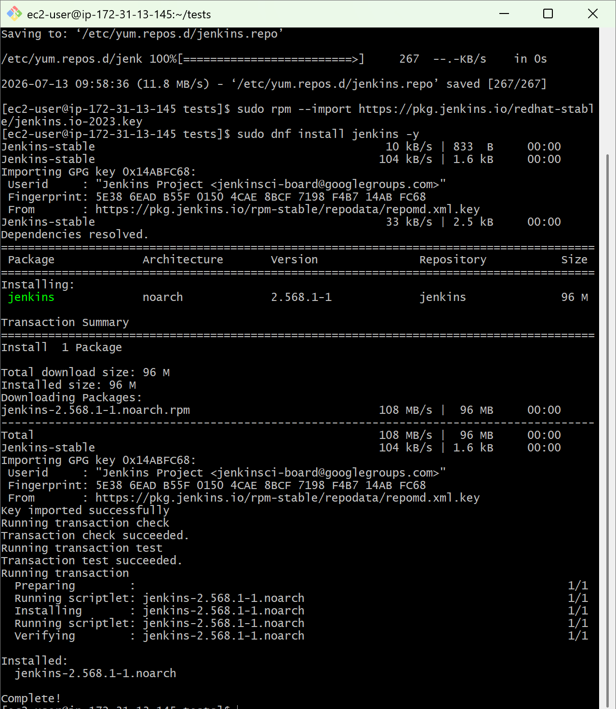
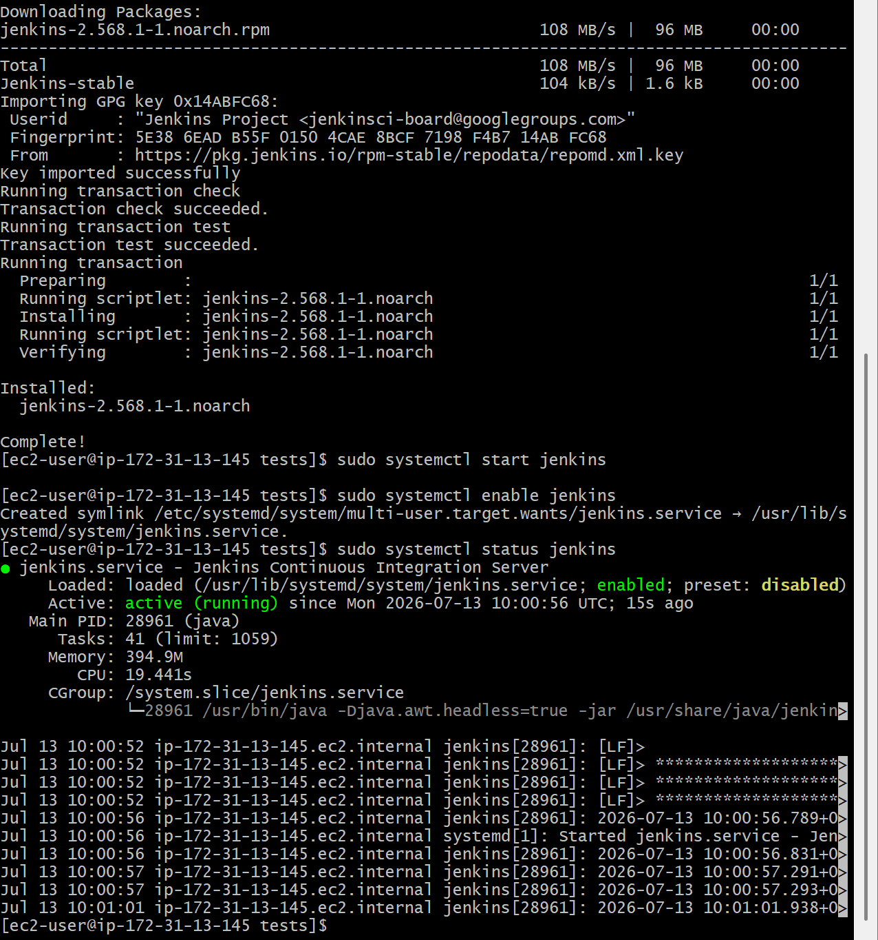

- Access Jenkins
Open your browser: public-ip:port number
http://44.205.5.21:8080

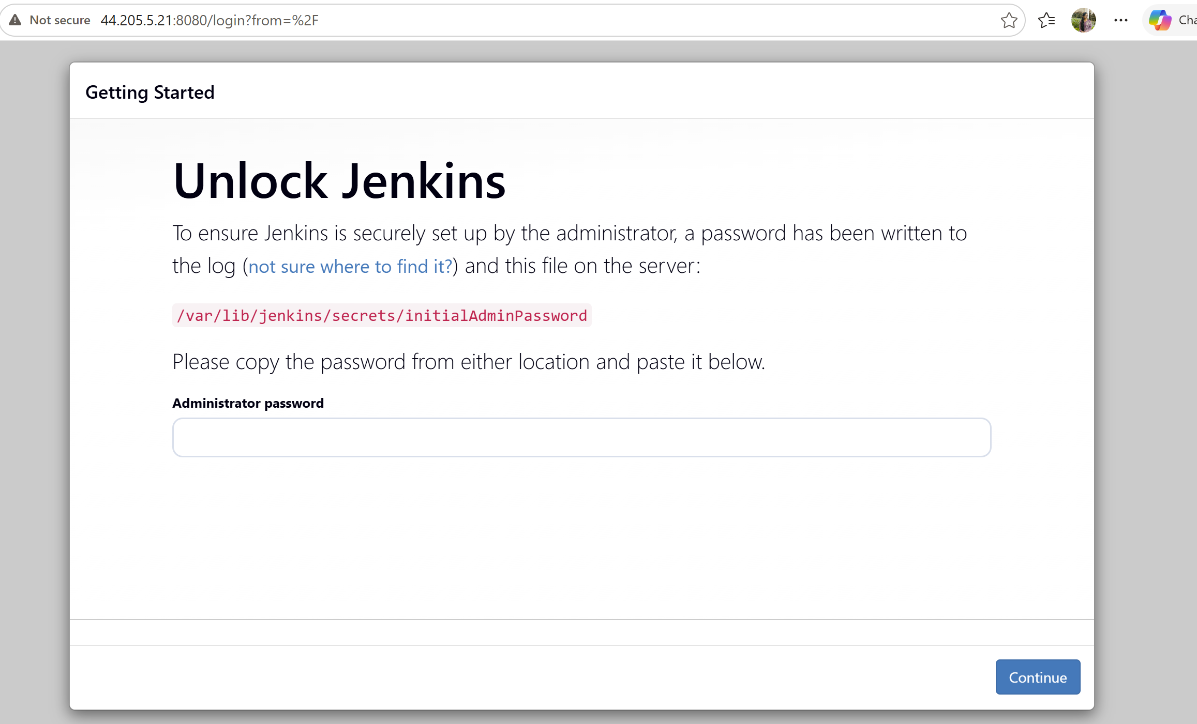

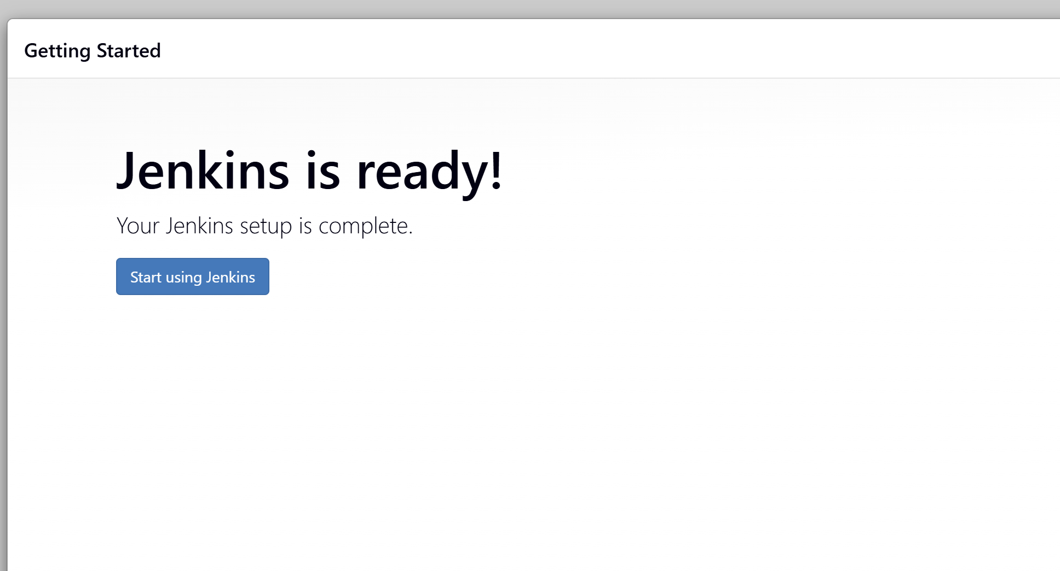
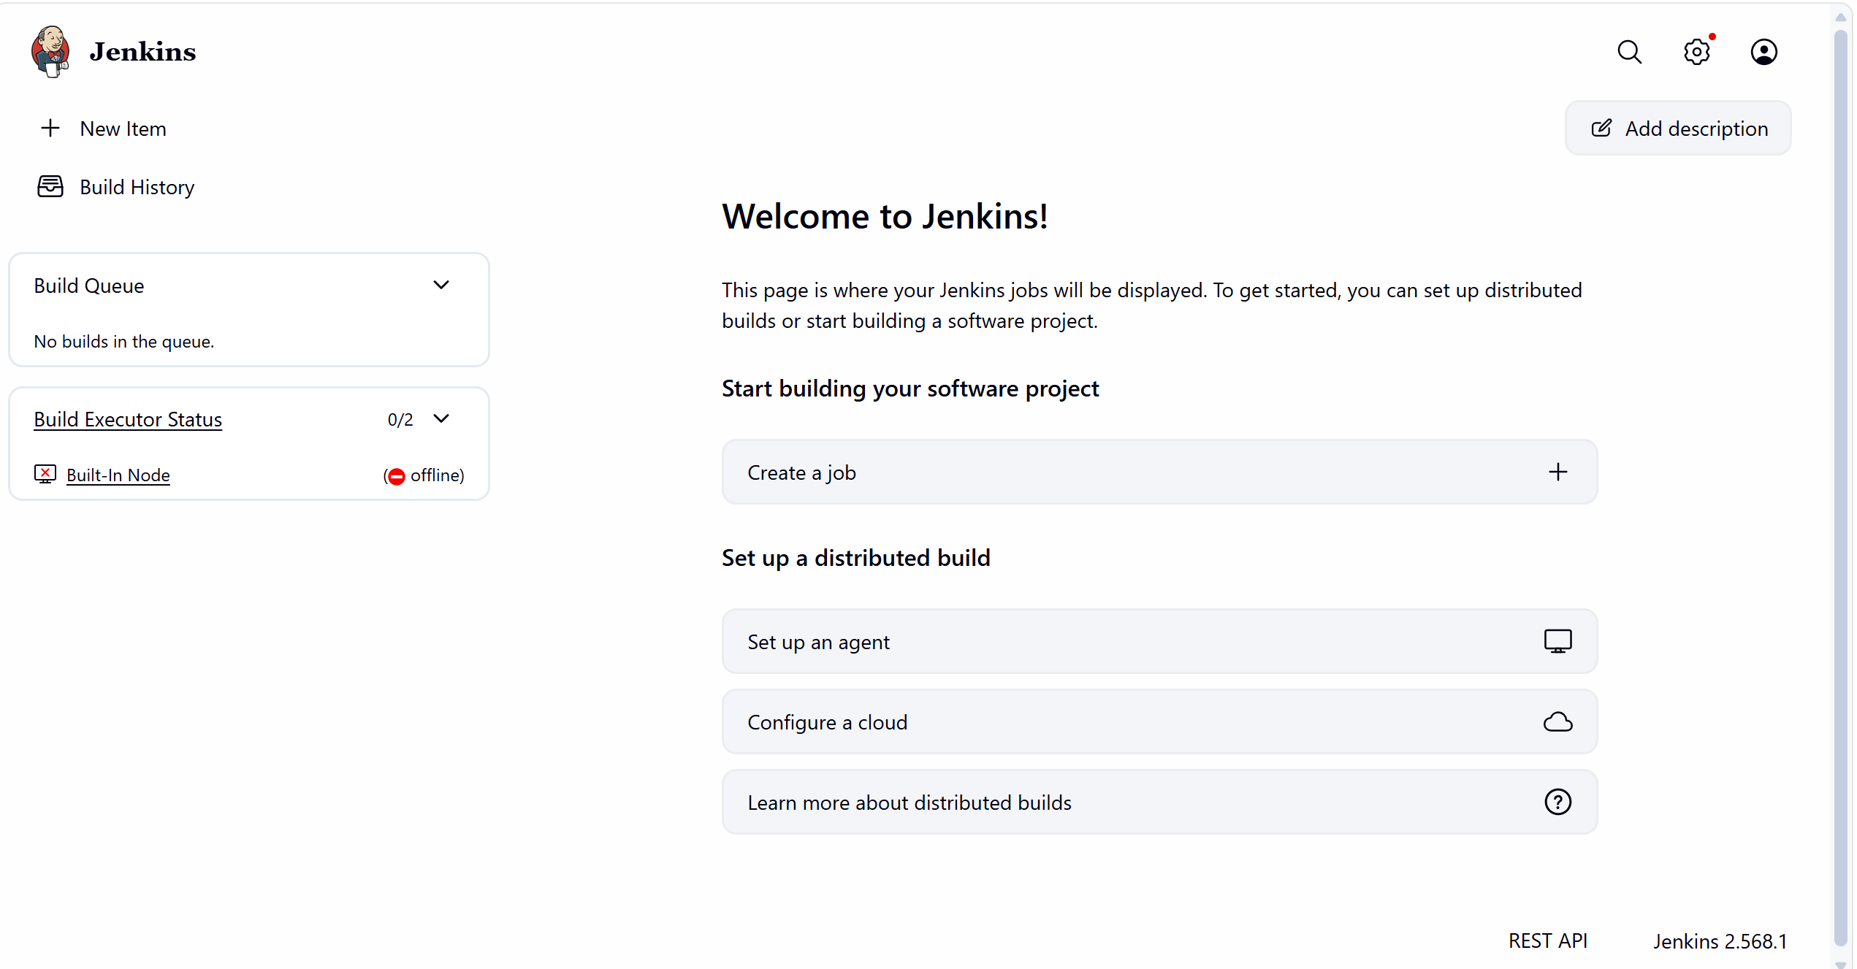
- Install Apache.
- Sudo dnf install httpd -y
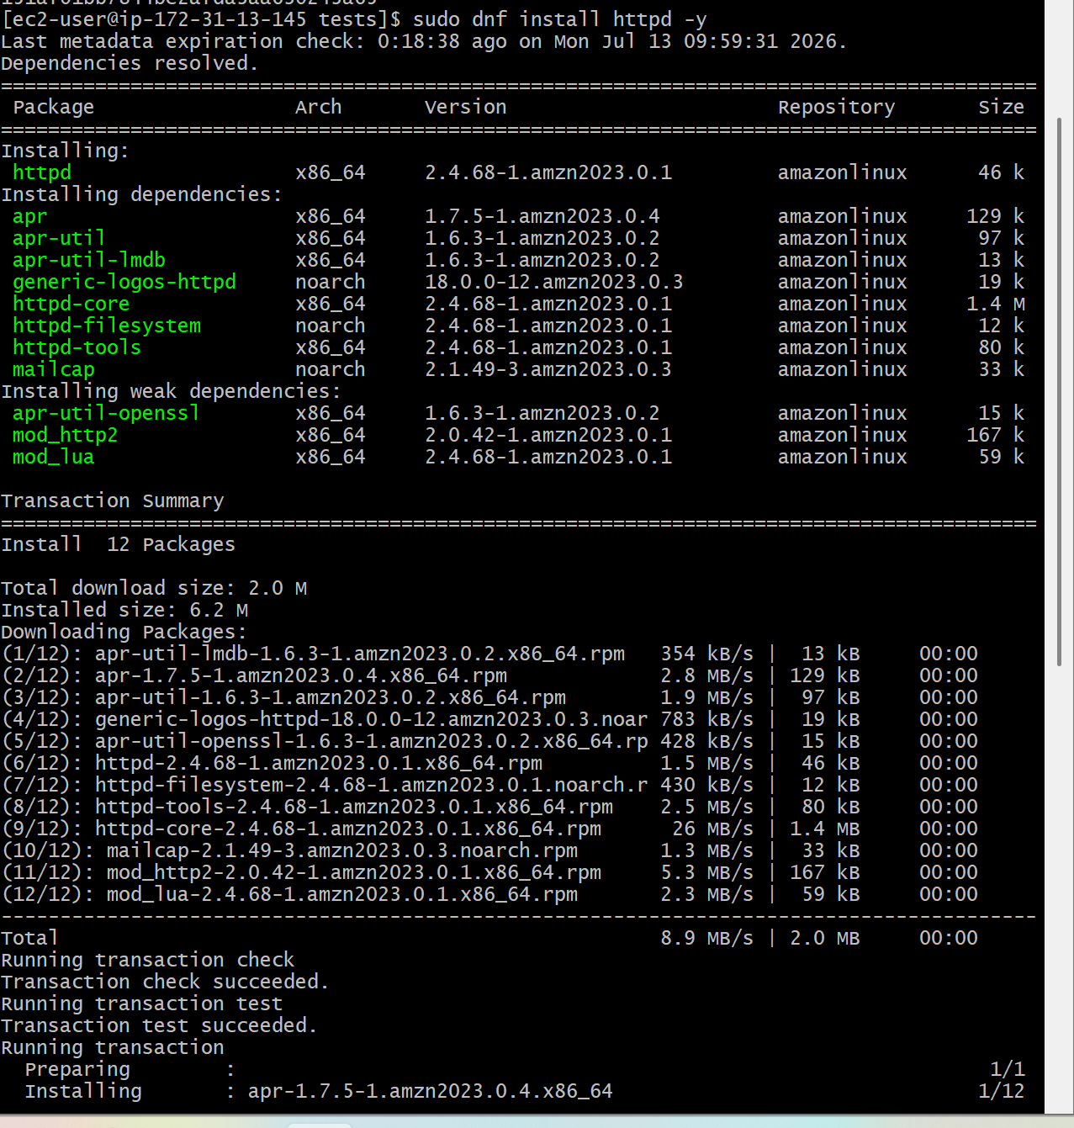
sudo systemctl start httpd
sudo systemctl enable httpd
sudo systemctl status httpd
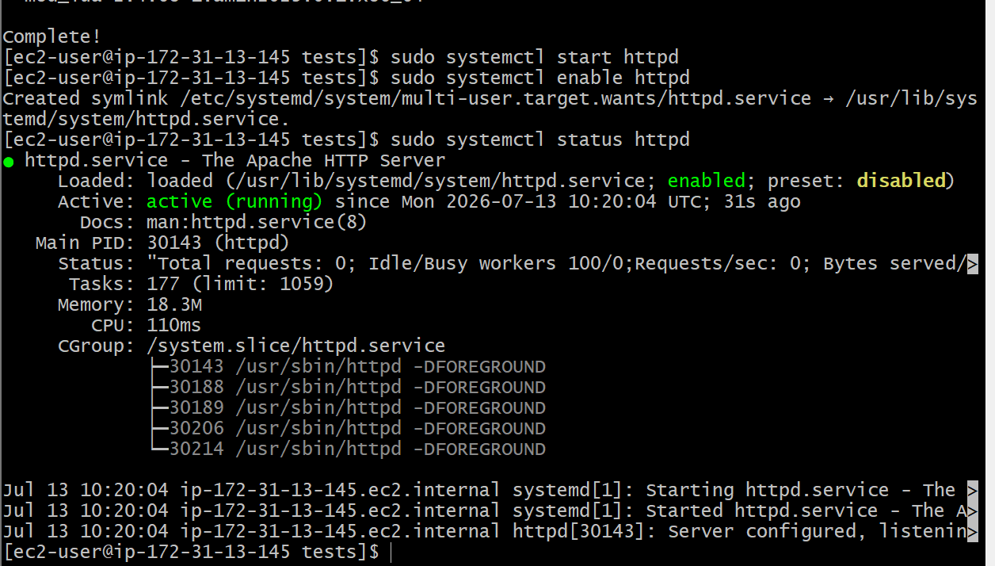
Open browser
Publicip:portnumber
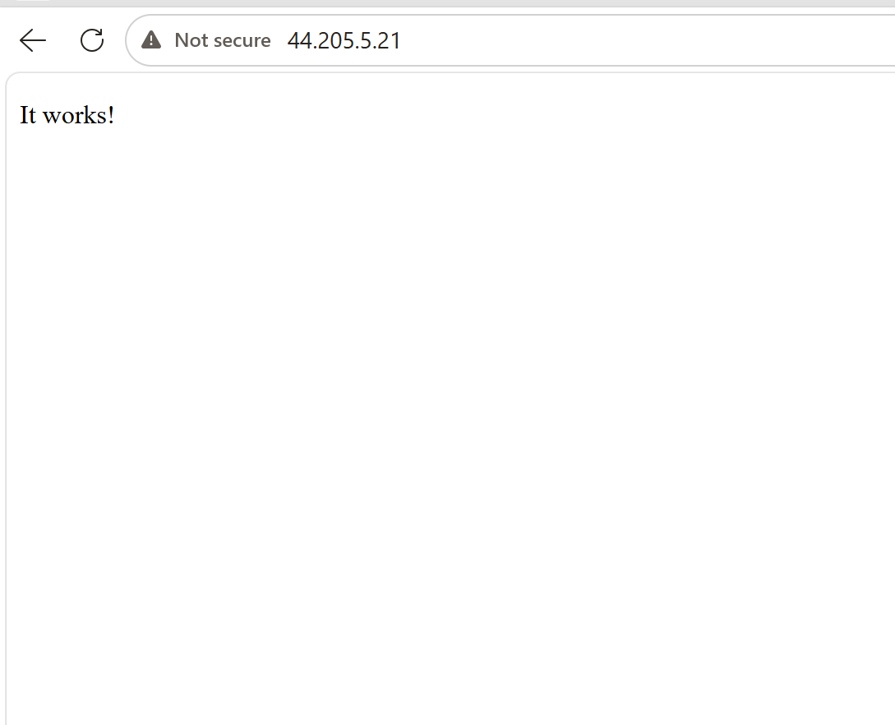

- Install Nginx.

sudo dnf install nginx -y
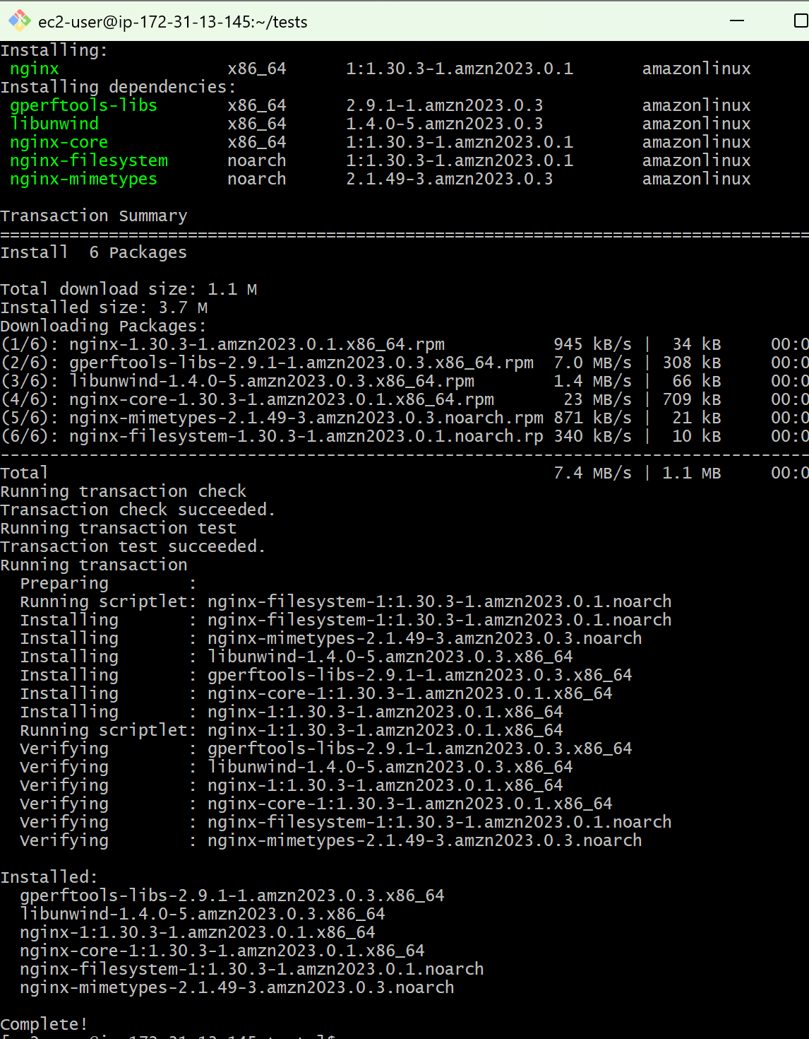

- Change Nginx Port
sudo vi /etc/nginx/nginx.conf

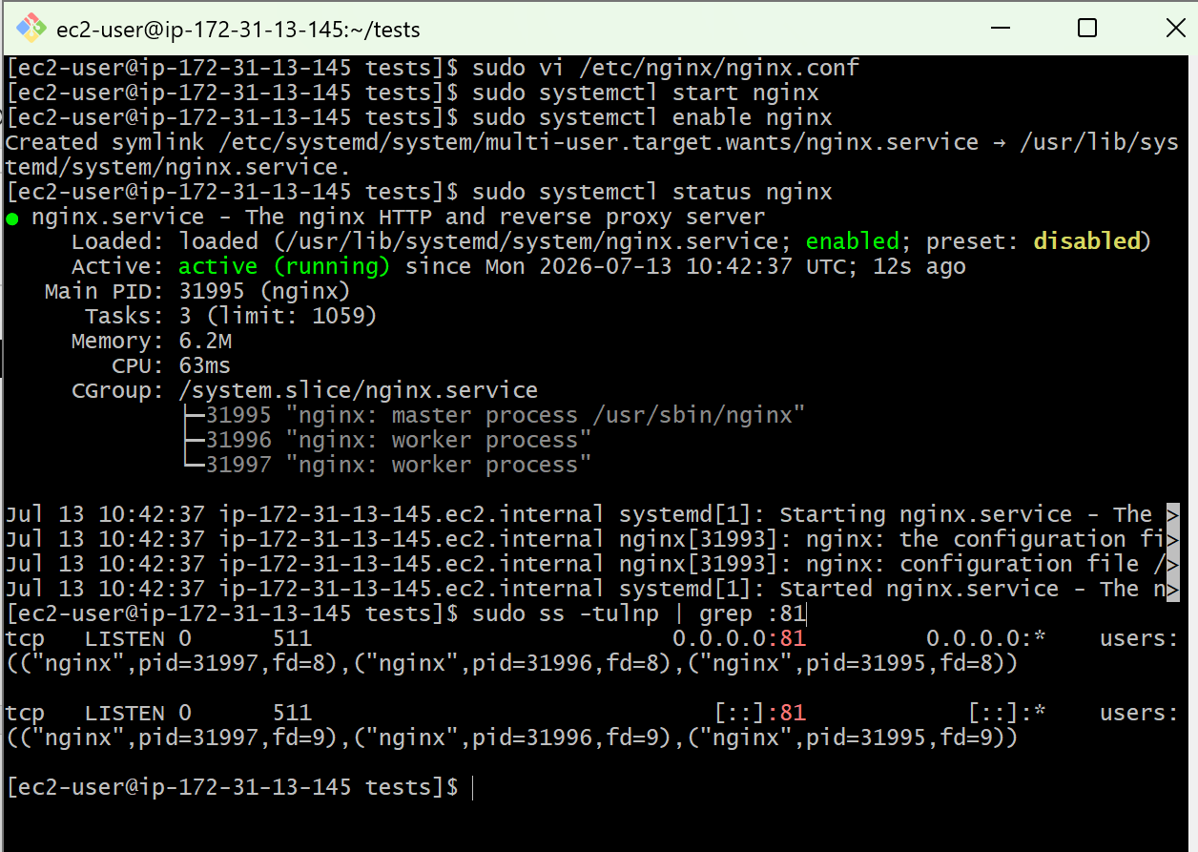

Open browser

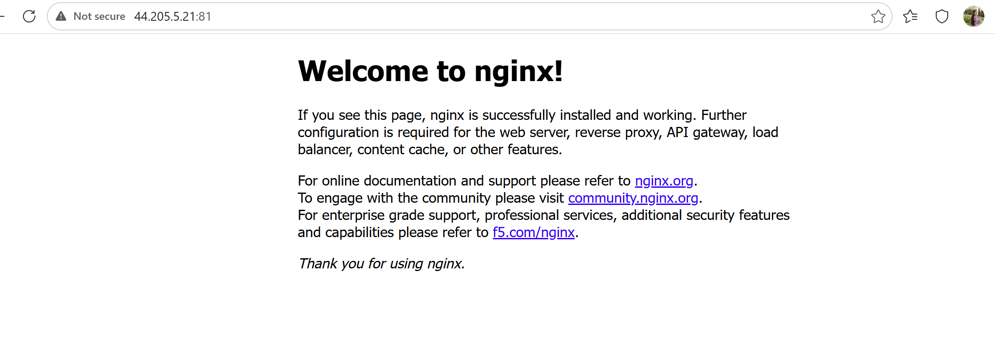

- Install Apache Tomcat.
- Check java --version
- Download Apache Tomcat
- Go to the /opt directory.
- Wget wget https://dlcdn.apache.org/tomcat/tomcat-10/v10.1.57/bin/apache-tomcat-10.1.57.tar.gz
- Extract the file
- tar -xvzf apache-tomcat-10.1.57.tar.gz
- sudo mv apache-tomcat-10.1.57 tomcat

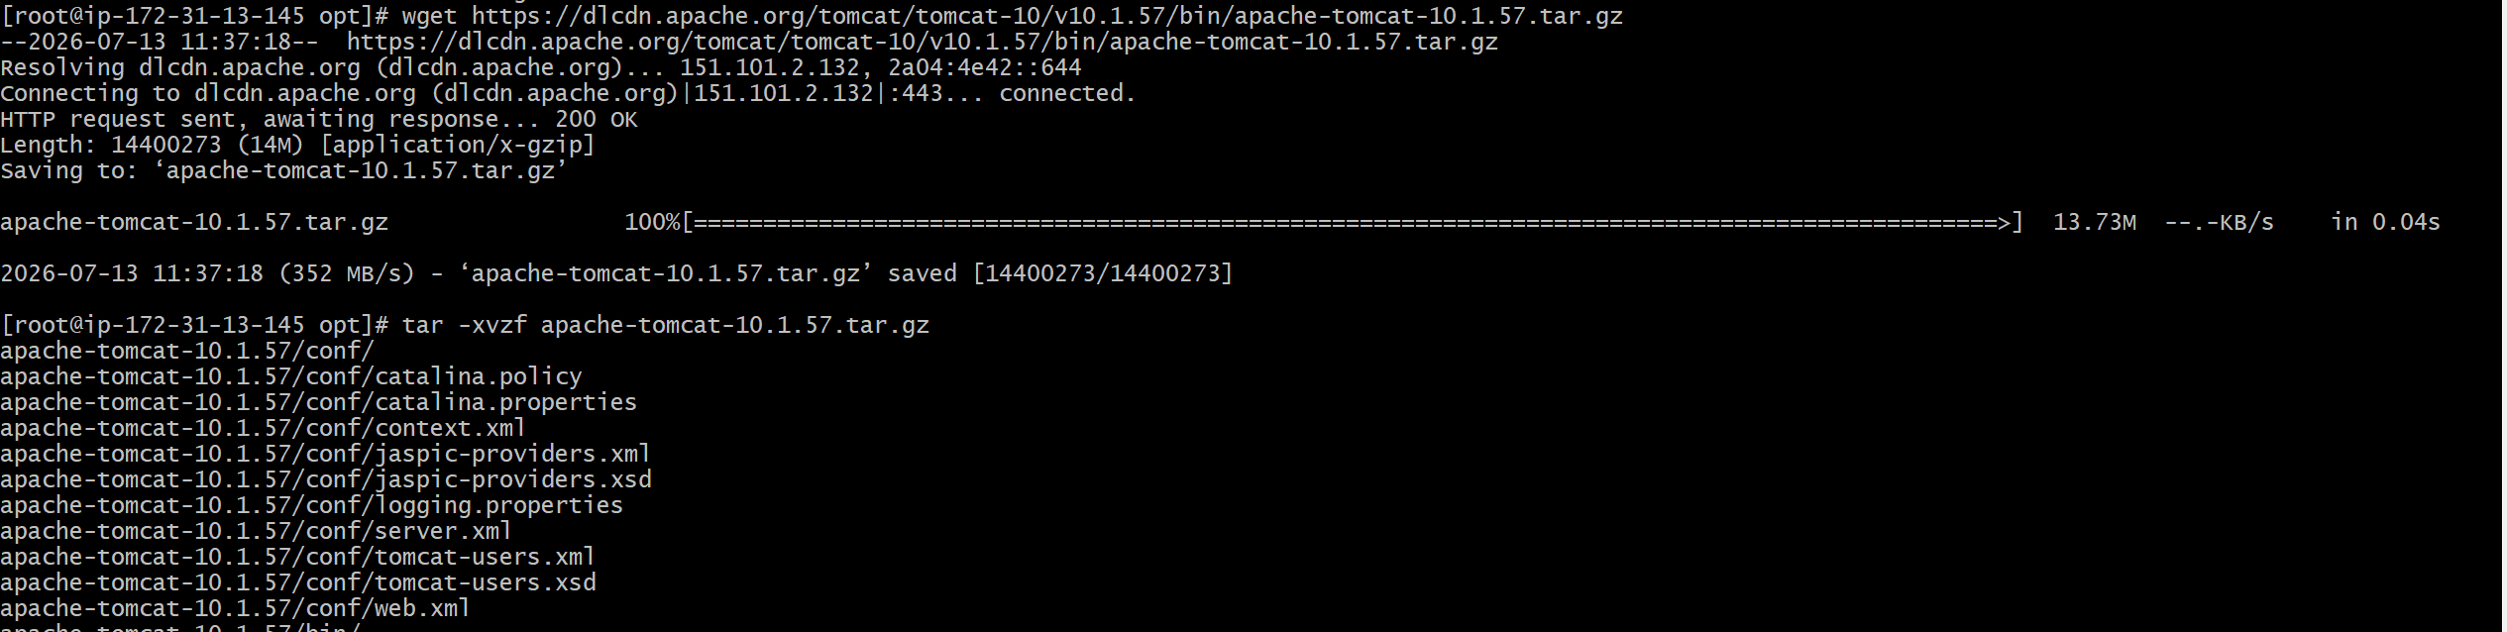
Give execute permission
- sudo chmod +x /opt/tomcat/bin/*.sh
- Start Tomcat
- cd /opt/tomcat/bin
- Start the server.
- ./startup.sh

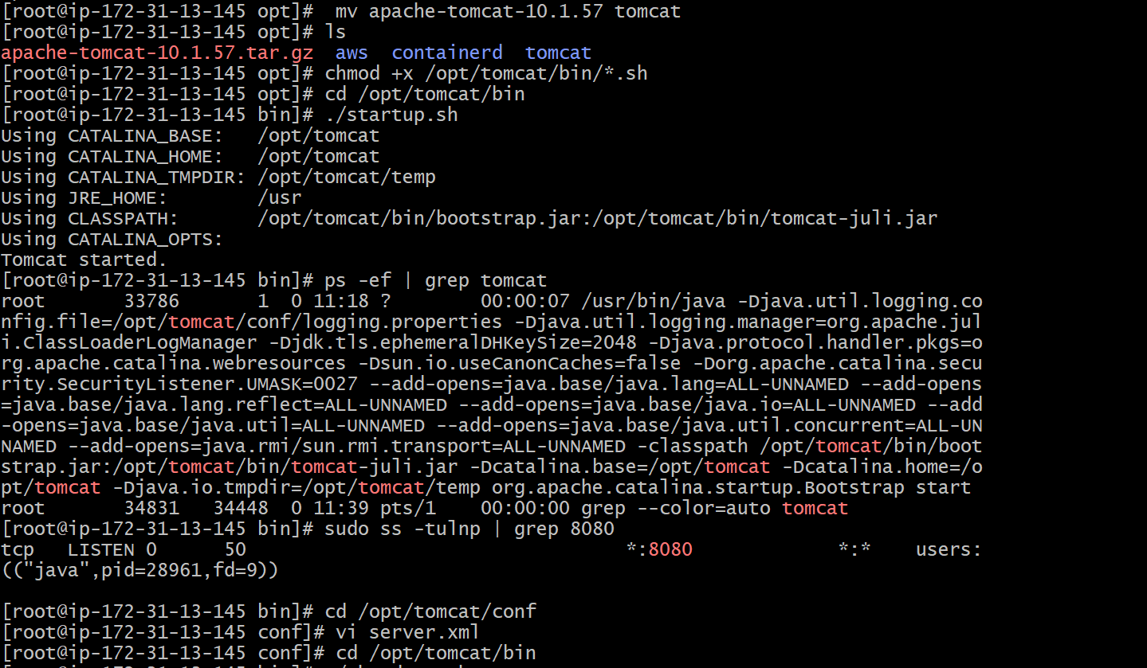

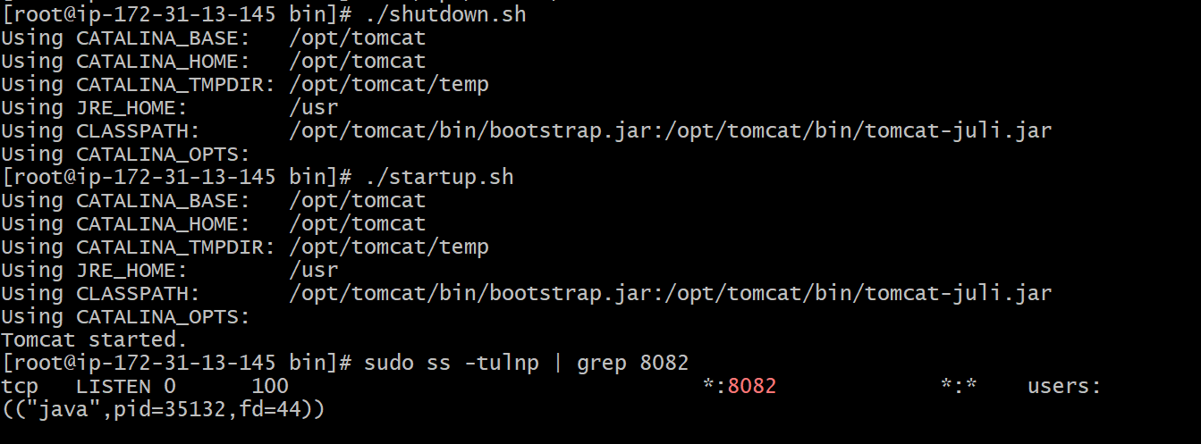
Check if Tomcat is running
Publicip:port number
